**Scenario 1:**

* I have the following requirements
* My application is three tier application
  + web tier
  + app tier
  + db tier
* Each tier needs have atleast two or more ec2 instances running in different availability zones or zones
* How will be your network design for AWS and Azure  
  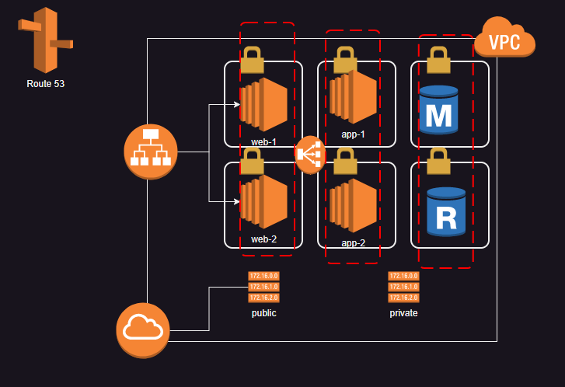  
  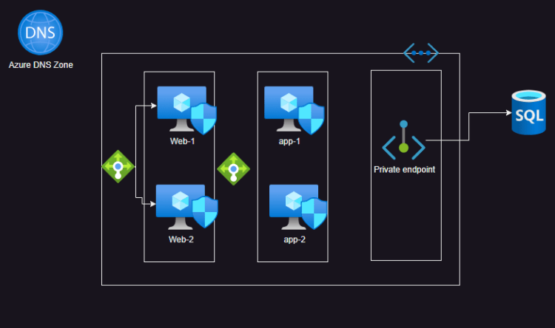

**Scenario 2**

* My organization is having a database on-prem due to regulatory reasons
* The Web application which uses this database needs to be on cloud
* Design a network in AWS and Azure for this
* Google Cloud Platform training

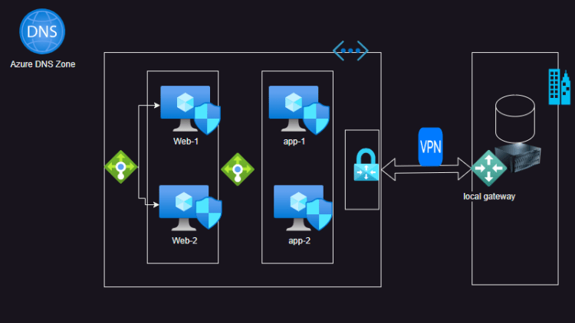  
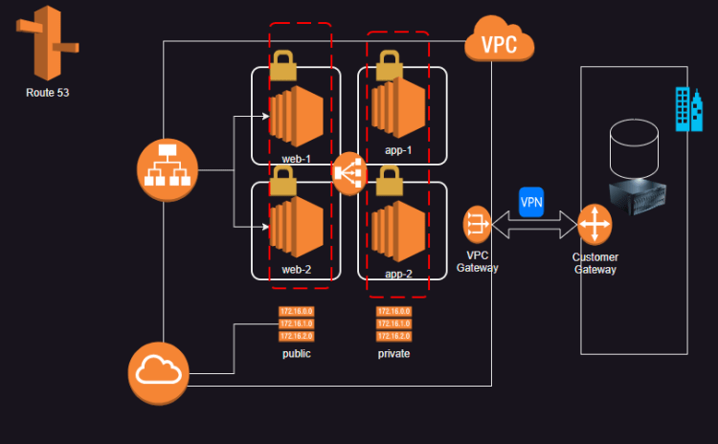

**Scenario 3**

* I have a popular web application which sells sweets online and i have global customers across north america and england
* I will have to setup 3 networks where the application will be hosted in 3 regions
  + two in us
  + one in uk
* When the customers access my application it needs to be served from region which is quickest.  
  